**Extra Practical’s**

**Bubble Sort**

<!DOCTYPE html>

<html lang="en">

<head>

<meta charset="UTF-8" />

<meta name="viewport" content="width=device-width, initial-scale=1.0" />

<title>Document</title>

</head>

<body>

<input id="inp" type="number" placeholder="enter a number" />

<button id="btn" type="submit">submit</button>

<button id="sortout">show sorted array on console</button>

<script>

var arr = [];

var k = 0;

function bubbleSort(arr1) {

var i, j;

var len = arr1.length;

var isSwapped = false;

for (i = 0; i < len; i++) {

isSwapped = false;

for (j = 0; j < len - i - 1; j++) {

if (arr1[j] > arr1[j + 1]) {

var temp = arr1[j];

arr1[j] = arr1[j + 1];

arr1[j + 1] = temp;

isSwapped = true;

}

}

// IF no two elements were swapped

// by inner loop, then break

if (!isSwapped) {

break;

}

}

// Print the array

console.log(arr1);

}

var ele = document.getElementById("btn");

ele.addEventListener("click", function () {

var val = document.getElementById("inp").value;

arr[k] = val;

k++;

document.getElementById("inp").value = "";

console.log(arr);

});

var sor = document.getElementById("sortout");

sor.addEventListener("click", function () {

bubbleSort(arr);

});

</script>

</body>

</html>

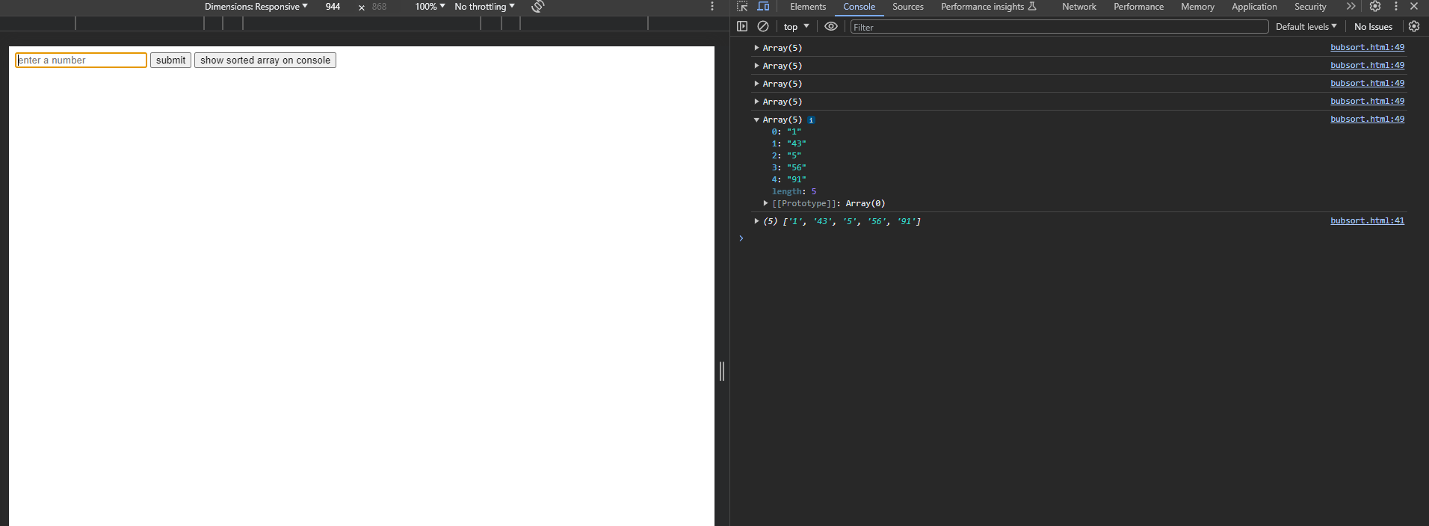

**Clock**

<!DOCTYPE html>

<html lang="en">

<head>

<meta charset="UTF-8">

<meta name="viewport" content="width=device-width, initial-scale=1.0">

<title>Digital clock</title>

</head>

<script>

function clock(){

let time=new Date()

let hours=time.getHours()

let minuits=time.getMinutes()

let seconds=time.getSeconds()

var pid=hours+":"+minuits+":"+seconds;

document.getElementById("timing").innerHTML=pid;

}

setInterval(clock,1000);

</script>

<body>

<p id="timing">

</p>

</body>

</html>

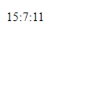

**Div Slider**

<!DOCTYPE html>

<html lang="en">

<head>

<meta charset="UTF-8">

<meta name="viewport" content="width=device-width, initial-scale=1.0">

<title>Toggle Paragraphs</title>

<script src="https://code.jquery.com/jquery-3.6.0.min.js"></script>

<style>

.div {

height: 40px;

font-size: 20px;

background-color: #3498db; /* Blue */

color: #fff; /* White */

transition: all 2s;

cursor: pointer;

box-shadow: 5px 5px 10px #2c3e50; /* Darker Blue */

margin: 15px;

text-shadow: 2px 2px 3px #000000; /* Slightly Darker Blue */

}

.div.active {

height: 160px;

font-size: 30px;

background-color: black; /* Red */

color: #e74c3c;

box-shadow: 5px 5px 10px #c0392b; /* Darker Red */

transition: all 2s;

text-shadow: 2px 2px 2px #922b21; /* Slightly Darker Red */

}

p {

box-shadow: -5px -5px 10px #717779; /* Gray */

background-color: #181616; /* Dark Gray */

height: 90px;

text-shadow: 2px 2px 2px #000; /* Black */

}

</style>

</head>

<body>

<div id="1" class="div">div1

<p class="para">para1</p>

</div>

<div id="2" class="div">div2

<p class="para">para2</p>

</div>

<div id="3" class="div">div3

<p class="para">para3</p>

</div>

<div id="4" class="div">div4

<p class="para">para4</p>

</div>

<script>

$(document).ready(function() {

$('p').hide();

$('.div').click(function() {

var isParagraphVisible = $(this).find('.para').is(':visible');

// Hide all paragraphs

$('.para').hide(2000);

// Reset the style for all divs

$('.div').removeClass('active');

if (!isParagraphVisible) {

$(this).find('.para').show(2000);

$(this).addClass('active');

}

});

});

</script>

</body>

</html>

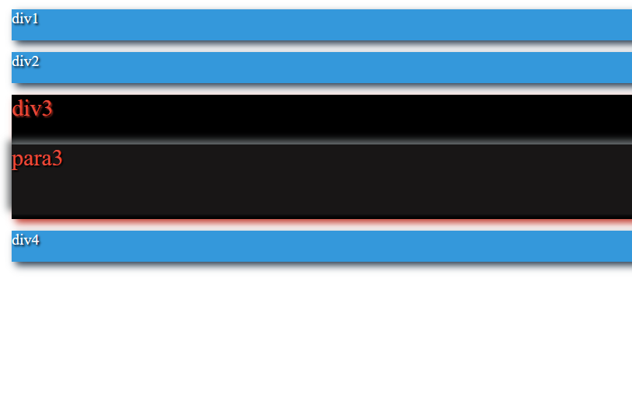

**Dynamic Table**

<!DOCTYPE html>

<html lang="en">

<head>

<meta charset="UTF-8">

<meta name="viewport" content="width=device-width, initial-scale=1.0">

<title>Document</title>

<style>

#1 {

display: grid;

grid-template-columns: 1fr 1fr;

gap: 8px;

}

.grid-item {

border: 1px solid black;

padding: 8px;

}

</style>

</head>

<body>

<div id="1"></div>

<div id="inputArea">

<input type="text" id="name" placeholder="Name">

<input type="text" id="email" placeholder="Email">

<input type="text" id="phone" placeholder="Phone Number">

<input type="text" id="gender" placeholder="Gender">

<button id="submitButton">Submit</button>

</div>

<script>

var ele = document.getElementById("1");

var inputArea = document.getElementById("inputArea");

function submitForm() {

var name = document.getElementById("name").value;

var email = document.getElementById("email").value;

var phone = document.getElementById("phone").value;

var gender = document.getElementById("gender").value;

createGridItem("Name:", name);

createGridItem("Email:", email);

createGridItem("Phone Number:", phone);

createGridItem("Gender:", gender);

document.getElementById("name").value = "";

document.getElementById("email ").value = "";

document.getElementById("phone").value = "";

document.getElementById("gender").value = "";

}

function createGridItem(label, value) {

var gridItem = document.createElement("div");

gridItem.classList.add("grid-item");

gridItem.textContent = label + " " + value;

ele.appendChild(gridItem);

}

document.getElementById("submitButton").addEventListener("click", submitForm);

</script>

</body>

</html>

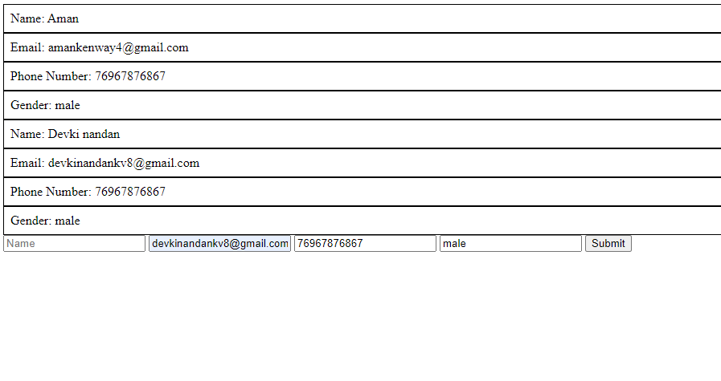

**Image Move**

<!DOCTYPE html>

<html>

<head>

<title>

IMAGE MOVE

</title>

<style type="text/css">

button{

background-color: black;

color: white;

padding: 8px;

}

.button{

text-align: center;

}

</style>

</head>

<body>

<img src="https://picsum.photos/200" id="i1">

<div class="button">

<button id="start" onclick="begin()">START</button>

<button id="stop" onclick="stop()">STOP</button>

<button id="reset" onclick="reset()">RESET</button>

</div>

<script type="text/javascript">

var a=document.getElementById('start');

var b=document.getElementById('stop');

var c=document.getElementById('reset');

var image=document.getElementById('i1');

var margin=0;

var interval;

function begin()

{

clearInterval(interval);

interval=setInterval(function(){

if(margin >= window.innerWidth - image.width){

margin=0;

}

image.style.marginLeft = margin+ "px";

margin+=5;

},10);

}

function stop(){

clearInterval(interval);

}

function reset(){

clearInterval(interval);

margin=0;

image.style.marginLeft = margin+"px";

}

</script>

</body>

</html>



**Image Zoom**

<html>

<head>

<title>Image Zoom</title>

<style type="text/css">

div{

border: 2px solid black;

padding: 10px;

}

p{

text-align:center;

}

img{

padding-left: 500px;

}

</style>

</head>

<body>

<div>

<p>Move over the image to zoom in and out of the Image to zoom out</p>

<img src="dog.jpg" id="img" >

</div>

<script type="text/javascript">

var image=document.getElementById('img');

image.onmouseover=function(){

image.style.height="400px";

image.style.width="350px";

}

image.onmouseout=function(){

image.style.height="200px";

image.style.width="150px";

}

</script>

</body>

</html>

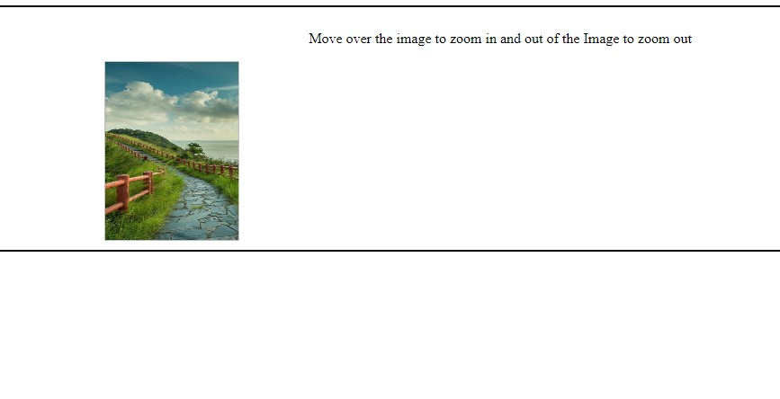

**Input Types**

<!DOCTYPE html>

<html lang="en">

<head>

<meta charset="UTF-8">

<meta name="viewport" content="width=device-width, initial-scale=1.0">

<style>

body {

display: flex;

justify-content: center;

align-items: center;

height: 100vh;

margin: 0;

background-color: #f0f0f0;

}

.form-container {

border: 2px solid #3498db;

box-shadow: 0 0 10px rgba(0, 0, 0, 0.2);

padding: 20px;

width: 400px;

background-color: #fff;

}

label {

display: block;

margin-bottom: 10px;

font-weight: bold;

}

input[type="text"],

input[type="password"],

input[type="email"],

input[type="number"],

textarea,

select {

width: 100%;

padding: 10px;

margin-bottom: 10px;

border: 1px solid #ccc;

border-radius: 4px;

transition: background-color 0.3s, color 0.3s;

}

input[type="text"]:hover,

input[type="password"]:hover,

input[type="email"]:hover,

input[type="number"]:hover,

textarea:hover,

select:hover {

background-color: #f5f5f5;

color: #333;

}

input[type="radio"],

input[type="checkbox"] {

margin-right: 5px;

}

.button-group {

margin-top: 20px;

}

.button-group button {

margin-right: 10px;

padding: 10px 20px;

background-color: #3498db;

color: #fff;

border: none;

border-radius: 4px;

cursor: pointer;

transition: background-color 0.3s, color 0.3s;

}

.button-group button:hover {

background-color: #258cd1;

}

</style>

</head>

<body>

<div class="form-container">

<form>

<label for="name">Question 1:</label>

<input type="text" id="name" name="name" placeholder="Answer 1">

<label for="email">Question 2:</label>

<input type="email" id="email" name="email" placeholder="Answer 2">

<label>Question 3:</label>

<div class="radio-group">

<input type="radio" id="radio1" name="question3" value="option1">

<label for="radio1">Option 1</label>

<input type="radio" id="radio2" name="question3" value="option2">

<label for="radio2">Option 2</label>

</div>

<label>Question 4:</label>

<div class="checkbox-group">

<input type="checkbox" id="checkbox1" name="question4" value="option1">

<label for="checkbox1">Option 1</label>

<input type="checkbox" id="checkbox2" name="question4" value="option2">

<label for="checkbox2">Option 2</label>

</div>

<label for="country">Question 5:</label>

<select id="country" name="question5">

<option value="option1">Option 1</option>

<option value="option2">Option 2</option>

</select>

<label for="message">Question 6:</label>

<textarea id="message" name="question6" rows="4" placeholder="Answer"></textarea>

<div class="button-group">

<button type="submit">Submit</button>

<button type="reset">Reset</button>

</div>

</form>

</div>

</body>

</html>

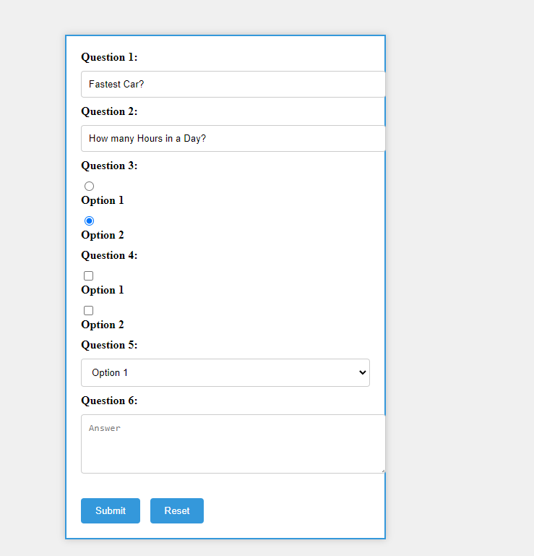

**Para Sib Count**

<!DOCTYPE html>

<html lang="en">

<head>

<meta charset="UTF-8">

<meta name="viewport" content="width=device-width, initial-scale=1.0">

<title>Document</title>

</head>

<body>

<div id="div1">

<p>para 1</p>

<p>para 2</p>

<p>para 3</p>

<p>para 4</p>

<div>divc 1</div>

<div>divc 2</div>

<div>divc 3</div>

</div>

<p>op1</p>

<p>op2</p>

<script>

var ele = document.getElementById("div1");

// Find the div with id "div1"

var div1 = document.getElementById("div1");

// Find the first paragraph inside div1

var firstPara = div1.firstElementChild;

// Initialize a counter for sibling paragraphs

var siblingCount = 0;

// Loop through the child nodes of div1

for (var i = 0; i < div1.childNodes.length; i++) {

var child = div1.childNodes[i];

// Check if the child node is a paragraph and not the first paragraph itself

if (child.nodeName === 'P' && child !== firstPara) {

siblingCount++;

}

}

// Print the count

console.log("Number of sibling paragraphs: " + siblingCount);

</script>

</body>

</html>

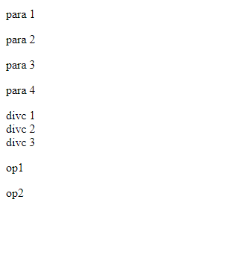

**Regular Exp Matching**

<!DOCTYPE html>

<html lang="en">

<head>

<meta charset="UTF-8">

<meta name="viewport" content="width=device-width, initial-scale=1.0">

<title>Document</title>

</head>

<body>

<script>

console.log(1)

var pn = "+917979097007"

const re = /[+91][0-9]{10}/;

console.log(pn.match(re));

var ea="pkmpkm123@gmail.com"

const re1=/([a-z0-9])+@[a-z]+[.][a-z]+([.][a-z]+)*/i;

console.log(ea.match(re1));

</script>

</body>

</html>

**Stack**

<html>

<head>

</head>

<body>

<form>

Enter the value : <input type="text" id="1">

<input type="button" value="Push" onclick=Push() id="2">

<input type="button" value="Pop" id="3"><br><br>

<textarea id="4" rows="20" cols="40"></textarea>

</form>

<script>

arr = new Array();

function Push(){

document.getElementById("4").value=document.getElementById("1").value

document.getElementById("1").value=""

}

// function Push(){

// while

// }

</script>

</body>

</html>

